Test 3 – try multiple different values for U, spatial and temporal resolution
- First model with conditions just like test 1 but with dt = 1 and so courant value is valid and below
Terminal:
This is a simulation calculator for the evolution of a pollutant concentration in a river
information needed for calulation: (ensure all inputs are +ve and non-zero)
/n choose simulation initialization:
test case 1 : where x_max = 20m, spacial resolution Δx = 0.2m, Model time = 300s, temporal resolution Δt=10s, flow velocity U=0.1m s−1, concentration μg m−^3 250 at x=0, 0 elsewhere)
test case 2 : initialise data for x_max, Δx and concentration distribution is read from initial_conditions.csv, with Model time = 300s, temporal resolution Δt=10s, flow velocity U=0.1m s−1
test case 3 : manual inputs
choose simulation initialization:
which test do you wish to run?3
what is the width of the model space (m) must be integer, x_max:20
Enter the space increment value (spatial resolution) (m), dx:0.2
Enter the model run time (s) must be integer, t_max:300
Enter the temporal resolution (s), dt:1
Enter the mean advective velocity (ms^-1), U:0.1
what is the start concentration at point x = 0:250
what is the start concentration at point x = 1:0
what is the start concentration at point x = 2:0
what is the start concentration at point x = 3:0
what is the start concentration at point x = 4:0
what is the start concentration at point x = 5:0
what is the start concentration at point x = 6:0
what is the start concentration at point x = 7:0
what is the start concentration at point x = 8:0
what is the start concentration at point x = 9:0
what is the start concentration at point x = 10:0
what is the start concentration at point x = 11:0
what is the start concentration at point x = 12:0
what is the start concentration at point x = 13:0
what is the start concentration at point x = 14:0
what is the start concentration at point x = 15:0
what is the start concentration at point x = 16:0
what is the start concentration at point x = 17:0
what is the start concentration at point x = 18:0
what is the start concentration at point x = 19:0
concentration distribution :
[250. 0. 0. 0. 0. 0. 0. 0. 0. 0. 0. 0. 0. 0.
0. 0. 0. 0. 0. 0. 0. 0. 0. 0. 0. 0. 0. 0.
0. 0. 0. 0. 0. 0. 0. 0. 0. 0. 0. 0. 0. 0.
0. 0. 0. 0. 0. 0. 0. 0. 0. 0. 0. 0. 0. 0.
0. 0. 0. 0. 0. 0. 0. 0. 0. 0. 0. 0. 0. 0.
0. 0. 0. 0. 0. 0. 0. 0. 0. 0. 0. 0. 0. 0.
0. 0. 0. 0. 0. 0. 0. 0. 0. 0. 0. 0. 0. 0.
0. 0. 0.]
model space:
[ 0. 0.2 0.4 0.6 0.8 1. 1.2 1.4 1.6 1.8 2. 2.2 2.4 2.6
2.8 3. 3.2 3.4 3.6 3.8 4. 4.2 4.4 4.6 4.8 5. 5.2 5.4
5.6 5.8 6. 6.2 6.4 6.6 6.8 7. 7.2 7.4 7.6 7.8 8. 8.2
8.4 8.6 8.8 9. 9.2 9.4 9.6 9.8 10. 10.2 10.4 10.6 10.8 11.
11.2 11.4 11.6 11.8 12. 12.2 12.4 12.6 12.8 13. 13.2 13.4 13.6 13.8
14. 14.2 14.4 14.6 14.8 15. 15.2 15.4 15.6 15.8 16. 16.2 16.4 16.6
16.8 17. 17.2 17.4 17.6 17.8 18. 18.2 18.4 18.6 18.8 19. 19.2 19.4
19.6 19.8 20. ]
model time:
300

choose initialization for calculation
calculator 1 (for questions 1,2,3) : regular advection calculation done
calculator 2 (for questions 4) : advection calculation modelled with exponential decay of concentration with time
calculator 3 (for questions 5) : advection calculation with variable velocity profile
which test do you wish to run?1
we will use the advection equation: ∂𝜃/∂𝑡 = ― 𝑈 * ∂𝜃/∂𝑥
courant number: 0.5
calculated result:
[[2.50000000e+02 0.00000000e+00 0.00000000e+00 ... 0.00000000e+00
0.00000000e+00 0.00000000e+00]
[0.00000000e+00 1.25000000e+02 0.00000000e+00 ... 0.00000000e+00
0.00000000e+00 0.00000000e+00]
[0.00000000e+00 6.25000000e+01 6.25000000e+01 ... 0.00000000e+00
0.00000000e+00 0.00000000e+00]
...
[0.00000000e+00 4.90909347e-88 1.45800076e-85 ... 7.40908561e-08
1.51205829e-07 3.03938989e-07]
[0.00000000e+00 2.45454673e-88 7.31454926e-86 ... 5.49230724e-08
1.12648342e-07 2.27572409e-07]
[0.00000000e+00 1.22727337e-88 3.66954737e-86 ... 4.06485115e-08
8.37857074e-08 1.70110376e-07]]
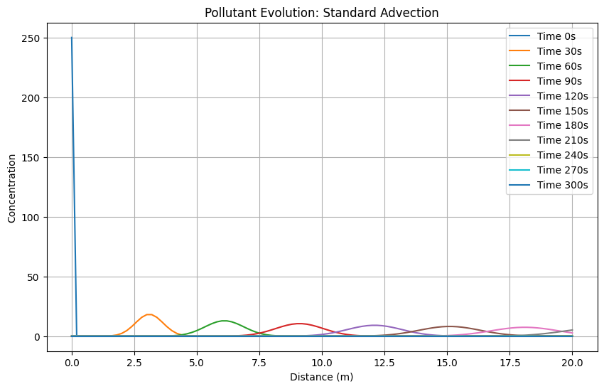
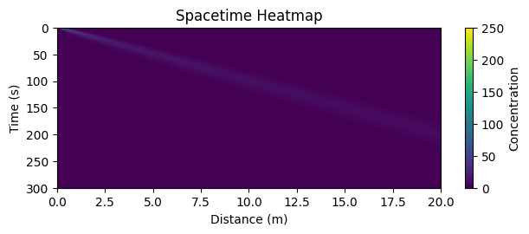
Plots look rights showing the concentration slowly fading with time and space

- Model case with all values same as test i but with different values of U. ie u = 0.01, u = 0.05 and u = 0.2
Test with u = 0.01
This is a simulation calculator for the evolution of a pollutant concentration in a river
information needed for calulation: (ensure all inputs are +ve and non-zero)
/n choose simulation initialization:
test case 1 : where x_max = 20m, spacial resolution Δx = 0.2m, Model time = 300s, temporal resolution Δt=10s, flow velocity U=0.1m s−1, concentration μg m−^3 250 at x=0, 0 elsewhere)
test case 2 : initialise data for x_max, Δx and concentration distribution is read from initial_conditions.csv, with Model time = 300s, temporal resolution Δt=10s, flow velocity U=0.1m s−1
test case 3 : manual inputs
choose simulation initialization:
which test do you wish to run?3
what is the width of the model space (m) must be integer, x_max:20
Enter the space increment value (spatial resolution) (m), dx:0.2
Enter the model run time (s) must be integer, t_max:300
Enter the temporal resolution (s), dt:1
Enter the mean advective velocity (ms^-1), U:0.01
what is the start concentration at point x = 0:250
what is the start concentration at point x = 1:0
what is the start concentration at point x = 2:0
what is the start concentration at point x = 3:0
what is the start concentration at point x = 4:0
what is the start concentration at point x = 5:0
what is the start concentration at point x = 6:0
what is the start concentration at point x = 7:0
what is the start concentration at point x = 8:0
what is the start concentration at point x = 9:0
what is the start concentration at point x = 10:0
what is the start concentration at point x = 11:0
what is the start concentration at point x = 12:0
what is the start concentration at point x = 13:0
what is the start concentration at point x = 14:0
what is the start concentration at point x = 15:0
what is the start concentration at point x = 16:0
what is the start concentration at point x = 17:0
what is the start concentration at point x = 18:0
what is the start concentration at point x = 19:0
concentration distribution :
[250. 0. 0. 0. 0. 0. 0. 0. 0. 0. 0. 0. 0. 0.
0. 0. 0. 0. 0. 0. 0. 0. 0. 0. 0. 0. 0. 0.
0. 0. 0. 0. 0. 0. 0. 0. 0. 0. 0. 0. 0. 0.
0. 0. 0. 0. 0. 0. 0. 0. 0. 0. 0. 0. 0. 0.
0. 0. 0. 0. 0. 0. 0. 0. 0. 0. 0. 0. 0. 0.
0. 0. 0. 0. 0. 0. 0. 0. 0. 0. 0. 0. 0. 0.
0. 0. 0. 0. 0. 0. 0. 0. 0. 0. 0. 0. 0. 0.
0. 0. 0.]
model space:
[ 0. 0.2 0.4 0.6 0.8 1. 1.2 1.4 1.6 1.8 2. 2.2 2.4 2.6
2.8 3. 3.2 3.4 3.6 3.8 4. 4.2 4.4 4.6 4.8 5. 5.2 5.4
5.6 5.8 6. 6.2 6.4 6.6 6.8 7. 7.2 7.4 7.6 7.8 8. 8.2
8.4 8.6 8.8 9. 9.2 9.4 9.6 9.8 10. 10.2 10.4 10.6 10.8 11.
11.2 11.4 11.6 11.8 12. 12.2 12.4 12.6 12.8 13. 13.2 13.4 13.6 13.8
14. 14.2 14.4 14.6 14.8 15. 15.2 15.4 15.6 15.8 16. 16.2 16.4 16.6
16.8 17. 17.2 17.4 17.6 17.8 18. 18.2 18.4 18.6 18.8 19. 19.2 19.4
19.6 19.8 20. ]
model time:
300

choose initialization for calculation
calculator 1 (for questions 1,2,3) : regular advection calculation done
calculator 2 (for questions 4) : advection calculation modelled with exponential decay of concentration with time
calculator 3 (for questions 5) : advection calculation with variable velocity profile
which test do you wish to run?1
we will use the advection equation: ∂𝜃/∂𝑡 = ― 𝑈 * ∂𝜃/∂𝑥
courant number: 0.049999999999999996
calculated result:
[[2.50000000e+02 0.00000000e+00 0.00000000e+00 ... 0.00000000e+00
0.00000000e+00 0.00000000e+00]
[0.00000000e+00 1.25000000e+01 0.00000000e+00 ... 0.00000000e+00
0.00000000e+00 0.00000000e+00]
[0.00000000e+00 1.18750000e+01 6.25000000e-01 ... 0.00000000e+00
0.00000000e+00 0.00000000e+00]
...
[0.00000000e+00 3.02566460e-06 4.72959150e-05 ... 4.17334995e-50
4.48265301e-51 4.74241334e-52]
[0.00000000e+00 2.87438137e-06 4.50824025e-05 ... 5.87798692e-50
6.34519534e-51 6.74661918e-52]
[0.00000000e+00 2.73066230e-06 4.29720015e-05 ... 8.26555537e-50
8.96692903e-51 9.58188588e-52]]
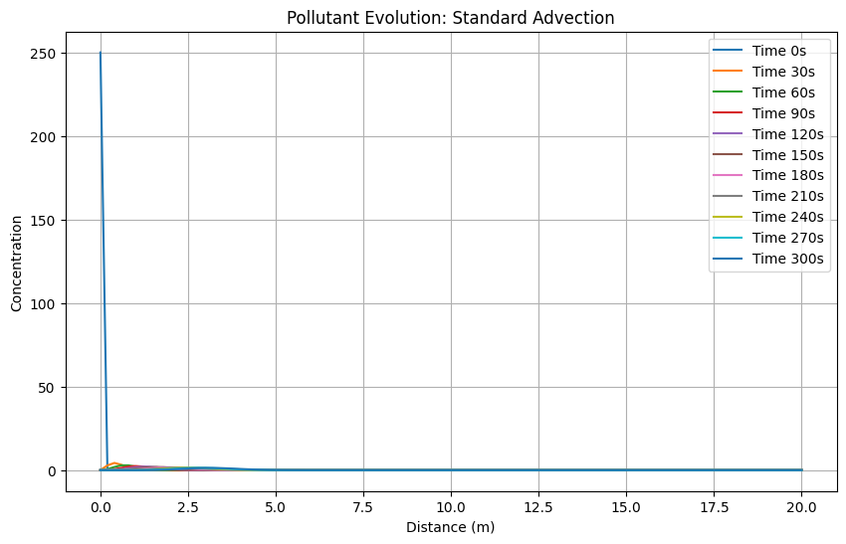
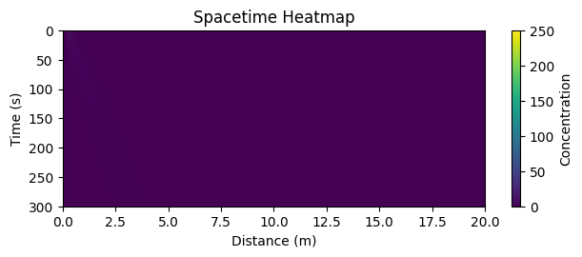
As we can see in the graph we expected movement of the pollutant to be much shorter as the flow is slower so it dos get transported much

Test with u = 0.05
This is a simulation calculator for the evolution of a pollutant concentration in a river
information needed for calculation: (ensure all inputs are +ve and non-zero)
/n choose simulation initialization:
test case 1 : where x_max = 20m, spacial resolution Δx = 0.2m, Model time = 300s, temporal resolution Δt=10s, flow velocity U=0.1m s−1, concentration μg m−^3 250 at x=0, 0 elsewhere)
test case 2 : initialise data for x_max, Δx and concentration distribution is read from initial_conditions.csv, with Model time = 300s, temporal resolution Δt=10s, flow velocity U=0.1m s−1
test case 3 : manual inputs
choose simulation initialization:
which test do you wish to run?3
what is the width of the model space (m) must be integer, x_max:20
Enter the space increment value (spatial resolution) (m), dx:0.2
Enter the model run time (s) must be integer, t_max:300
Enter the temporal resolution (s), dt:1
Enter the mean advective velocity (ms^-1), U:0.05
what is the start concentration at point x = 0:250
what is the start concentration at point x = 1:0
what is the start concentration at point x = 2:0
what is the start concentration at point x = 3:0
what is the start concentration at point x = 4:0
what is the start concentration at point x = 5:0
what is the start concentration at point x = 6:0
what is the start concentration at point x = 7:0
what is the start concentration at point x = 8:0
what is the start concentration at point x = 9:0
what is the start concentration at point x = 10:0
what is the start concentration at point x = 11:0
what is the start concentration at point x = 12:0
what is the start concentration at point x = 13:0
what is the start concentration at point x = 14:0
what is the start concentration at point x = 15:0
what is the start concentration at point x = 16:0
what is the start concentration at point x = 17:0
what is the start concentration at point x = 18:0
what is the start concentration at point x = 19:0
concentration distribution :
[250. 0. 0. 0. 0. 0. 0. 0. 0. 0. 0. 0. 0. 0.
0. 0. 0. 0. 0. 0. 0. 0. 0. 0. 0. 0. 0. 0.
0. 0. 0. 0. 0. 0. 0. 0. 0. 0. 0. 0. 0. 0.
0. 0. 0. 0. 0. 0. 0. 0. 0. 0. 0. 0. 0. 0.
0. 0. 0. 0. 0. 0. 0. 0. 0. 0. 0. 0. 0. 0.
0. 0. 0. 0. 0. 0. 0. 0. 0. 0. 0. 0. 0. 0.
0. 0. 0. 0. 0. 0. 0. 0. 0. 0. 0. 0. 0. 0.
0. 0. 0.]
model space:
[ 0. 0.2 0.4 0.6 0.8 1. 1.2 1.4 1.6 1.8 2. 2.2 2.4 2.6
2.8 3. 3.2 3.4 3.6 3.8 4. 4.2 4.4 4.6 4.8 5. 5.2 5.4
5.6 5.8 6. 6.2 6.4 6.6 6.8 7. 7.2 7.4 7.6 7.8 8. 8.2
8.4 8.6 8.8 9. 9.2 9.4 9.6 9.8 10. 10.2 10.4 10.6 10.8 11.
11.2 11.4 11.6 11.8 12. 12.2 12.4 12.6 12.8 13. 13.2 13.4 13.6 13.8
14. 14.2 14.4 14.6 14.8 15. 15.2 15.4 15.6 15.8 16. 16.2 16.4 16.6
16.8 17. 17.2 17.4 17.6 17.8 18. 18.2 18.4 18.6 18.8 19. 19.2 19.4
19.6 19.8 20. ]
model time:
300

choose initialization for calculation
calculator 1 (for questions 1,2,3) : regular advection calculation done
calculator 2 (for questions 4) : advection calculation modelled with exponential decay of concentration with time.
calculator 3 (for questions 5) : advection calculation with variable velocity profile
which test do you wish to run?1
we will use the advection equation: ∂𝜃/∂𝑡 = ― 𝑈 * ∂𝜃/∂𝑥
courant number: 0.25
calculated result:
[[2.50000000e+02 0.00000000e+00 0.00000000e+00 ... 0.00000000e+00
0.00000000e+00 0.00000000e+00]
[0.00000000e+00 6.25000000e+01 0.00000000e+00 ... 0.00000000e+00
0.00000000e+00 0.00000000e+00]
[0.00000000e+00 4.68750000e+01 1.56250000e+01 ... 0.00000000e+00
0.00000000e+00 0.00000000e+00]
...
[0.00000000e+00 4.88737029e-36 4.83849659e-34 ... 3.86435351e-02
2.62881191e-02 1.76139249e-02]
[0.00000000e+00 3.66552772e-36 3.64109087e-34 ... 4.29693040e-02
2.93769731e-02 1.97824735e-02]
[0.00000000e+00 2.74914579e-36 2.73998197e-34 ... 4.77023090e-02
3.27750558e-02 2.21810984e-02]]
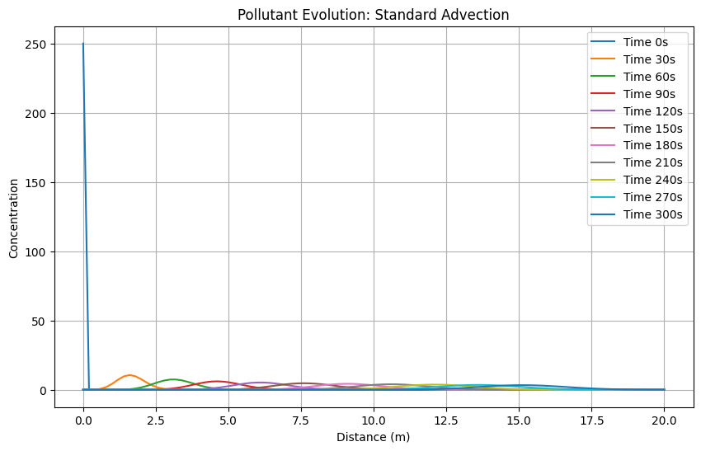
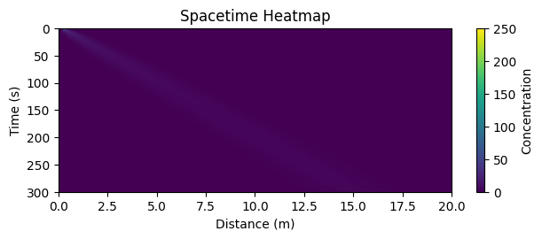
We can see in the plot that the graph has been squeezed to the left
Test with u = 0.2
This is a simulation calculator for the evolution of a pollutant concentration in a river
information needed for calulation: (ensure all inputs are +ve and non-zero)
/n choose simulation initialization:
test case 1 : where x_max = 20m, spacial resolution Δx = 0.2m, Model time = 300s, temporal resolution Δt=10s, flow velocity U=0.1m s−1, concentration μg m−^3 250 at x=0, 0 elsewhere)
test case 2 : initialise data for x_max, Δx and concentration distribution is read from initial_conditions.csv, with Model time = 300s, temporal resolution Δt=10s, flow velocity U=0.1m s−1
test case 3 : manual inputs
choose simulation initialization:
which test do you wish to run?3
what is the width of the model space (m) must be integer, x_max:20
Enter the space increment value (spatial resolution) (m), dx:0.2
Enter the model run time (s) must be integer, t_max:300
Enter the temporal resolution (s), dt:1
Enter the mean advective velocity (ms^-1), U:0.2
what is the start concentration at point x = 0:250
what is the start concentration at point x = 1:0
what is the start concentration at point x = 2:0
what is the start concentration at point x = 3:0
what is the start concentration at point x = 4:0
what is the start concentration at point x = 5:0
what is the start concentration at point x = 6:0
what is the start concentration at point x = 7:0
what is the start concentration at point x = 8:0
what is the start concentration at point x = 9:0
what is the start concentration at point x = 10:0
what is the start concentration at point x = 11:0
what is the start concentration at point x = 12:0
what is the start concentration at point x = 13:0
what is the start concentration at point x = 14:0
what is the start concentration at point x = 15:0
what is the start concentration at point x = 16:0
what is the start concentration at point x = 17:0
what is the start concentration at point x = 18:0
what is the start concentration at point x = 19:0
concentration distribution :
[250. 0. 0. 0. 0. 0. 0. 0. 0. 0. 0. 0. 0. 0.
0. 0. 0. 0. 0. 0. 0. 0. 0. 0. 0. 0. 0. 0.
0. 0. 0. 0. 0. 0. 0. 0. 0. 0. 0. 0. 0. 0.
0. 0. 0. 0. 0. 0. 0. 0. 0. 0. 0. 0. 0. 0.
0. 0. 0. 0. 0. 0. 0. 0. 0. 0. 0. 0. 0. 0.
0. 0. 0. 0. 0. 0. 0. 0. 0. 0. 0. 0. 0. 0.
0. 0. 0. 0. 0. 0. 0. 0. 0. 0. 0. 0. 0. 0.
0. 0. 0.]
model space:
[ 0. 0.2 0.4 0.6 0.8 1. 1.2 1.4 1.6 1.8 2. 2.2 2.4 2.6
2.8 3. 3.2 3.4 3.6 3.8 4. 4.2 4.4 4.6 4.8 5. 5.2 5.4
5.6 5.8 6. 6.2 6.4 6.6 6.8 7. 7.2 7.4 7.6 7.8 8. 8.2
8.4 8.6 8.8 9. 9.2 9.4 9.6 9.8 10. 10.2 10.4 10.6 10.8 11.
11.2 11.4 11.6 11.8 12. 12.2 12.4 12.6 12.8 13. 13.2 13.4 13.6 13.8
14. 14.2 14.4 14.6 14.8 15. 15.2 15.4 15.6 15.8 16. 16.2 16.4 16.6
16.8 17. 17.2 17.4 17.6 17.8 18. 18.2 18.4 18.6 18.8 19. 19.2 19.4
19.6 19.8 20. ]
model time:
300

choose initialization for calculation
calculator 1 (for questions 1,2,3) : regular advection calculation done
calculator 2 (for questions 4) : advection calculation modelled with exponential decay of concentration with time
calculator 3 (for questions 5) : advection calculation with variable velocity profile
which test do you wish to run?1
we will use the advection equation: ∂𝜃/∂𝑡 = ― 𝑈 * ∂𝜃/∂𝑥
courant number: 1.0
calculated result:
[[250. 0. 0. ... 0. 0. 0.]
[ 0. 250. 0. ... 0. 0. 0.]
[ 0. 0. 250. ... 0. 0. 0.]
...
[ 0. 0. 0. ... 0. 0. 0.]
[ 0. 0. 0. ... 0. 0. 0.]
[ 0. 0. 0. ... 0. 0. 0.]]
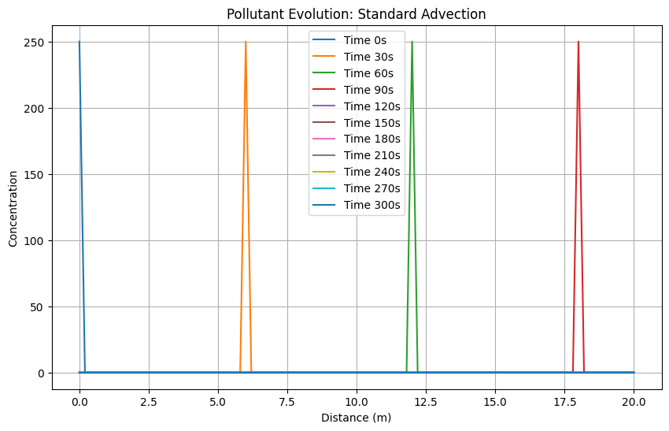
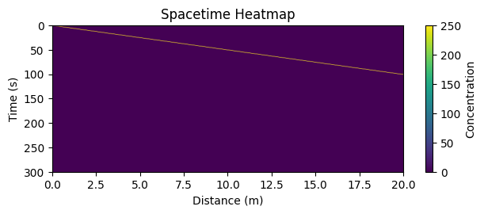
We expected the graph to be more spaced out for this test. We can also examine that the speed of flow is at the point where the pollutant is not spread but rather moved along with the flow.

- Now to experiment with different values for the spatial resolution: test cases for dx = 0.4, 0.8 (to abide by courant we can choose any u <1) , with all the same parameters for test i.
Test dx = 0.4
This is a simulation calculator for the evolution of a pollutant concentration in a river
information needed for calculation: (ensure all inputs are +ve and non-zero)

choose simulation initialization:
test case 1 : where x_max = 20m, spacial resolution Δx = 0.2m, Model time = 300s, temporal resolution Δt=10s, flow velocity U=0.1m s−1, concentration μg m−^3 250 at x=0, 0 elsewhere)
test case 2 : initialise data for x_max, Δx and concentration distribution is read from initial_conditions.csv, with Model time = 300s, temporal resolution Δt=10s, flow velocity U=0.1m s−1
test case 3 : manual inputs
choose simulation initialization:
which test do you wish to run?3
what is the width of the model space (m) must be integer, x_max:20
Enter the space increment value (spatial resolution) (m), dx:0.4
Enter the model run time (s) must be integer, t_max:300
Enter the temporal resolution (s), dt:1
Enter the mean advective velocity (ms^-1), U:0.1
what is the start concentration at point x = 0:250
what is the start concentration at point x = 1:0
what is the start concentration at point x = 2:0
what is the start concentration at point x = 3:0
what is the start concentration at point x = 4:0
what is the start concentration at point x = 5:0
what is the start concentration at point x = 6:0
what is the start concentration at point x = 7:0
what is the start concentration at point x = 8:0
what is the start concentration at point x = 9:0
what is the start concentration at point x = 10:0
what is the start concentration at point x = 11:0
what is the start concentration at point x = 12:0
what is the start concentration at point x = 13:0
what is the start concentration at point x = 14:0
what is the start concentration at point x = 15:0
what is the start concentration at point x = 16:0
what is the start concentration at point x = 17:0
what is the start concentration at point x = 18:0
what is the start concentration at point x = 19:0
concentration distribution :
[250. 0. 0. 0. 0. 0. 0. 0. 0. 0. 0. 0. 0. 0.
0. 0. 0. 0. 0. 0. 0. 0. 0. 0. 0. 0. 0. 0.
0. 0. 0. 0. 0. 0. 0. 0. 0. 0. 0. 0. 0. 0.
0. 0. 0. 0. 0. 0. 0. 0. 0.]
model space:
[ 0. 0.4 0.8 1.2 1.6 2. 2.4 2.8 3.2 3.6 4. 4.4 4.8 5.2
5.6 6. 6.4 6.8 7.2 7.6 8. 8.4 8.8 9.2 9.6 10. 10.4 10.8
11.2 11.6 12. 12.4 12.8 13.2 13.6 14. 14.4 14.8 15.2 15.6 16. 16.4
16.8 17.2 17.6 18. 18.4 18.8 19.2 19.6 20. ]
model time:
300

choose initialization for calculation
calculator 1 (for questions 1,2,3) : regular advection calculation done
calculator 2 (for questions 4) : advection calculation modelled with exponential decay of concentration with time
calculator 3 (for questions 5) : advection calculation with variable velocity profile
which test do you wish to run?1
we will use the advection equation: ∂𝜃/∂𝑡 = ― 𝑈 * ∂𝜃/∂𝑥
courant number: 0.25
calculated result:
[[2.50000000e+02 0.00000000e+00 0.00000000e+00 ... 0.00000000e+00
0.00000000e+00 0.00000000e+00]
[0.00000000e+00 6.25000000e+01 0.00000000e+00 ... 0.00000000e+00
0.00000000e+00 0.00000000e+00]
[0.00000000e+00 4.68750000e+01 1.56250000e+01 ... 0.00000000e+00
0.00000000e+00 0.00000000e+00]
...
[0.00000000e+00 4.88737029e-36 4.83849659e-34 ... 2.51719386e-03
4.37012822e-03 7.40246210e-03]
[0.00000000e+00 3.66552772e-36 3.64109087e-34 ... 2.24140569e-03
3.90689463e-03 6.64437863e-03]
[0.00000000e+00 2.74914579e-36 2.73998197e-34 ... 1.99458423e-03
3.49052240e-03 5.96000763e-03]]
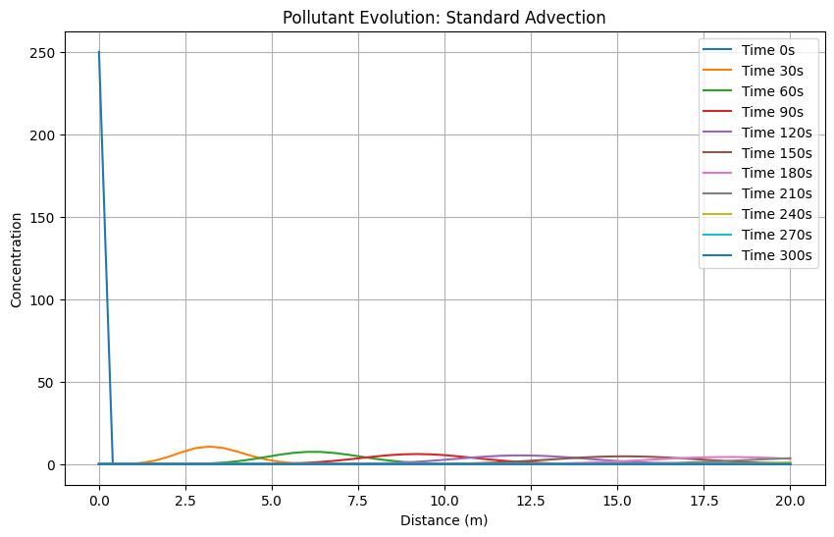
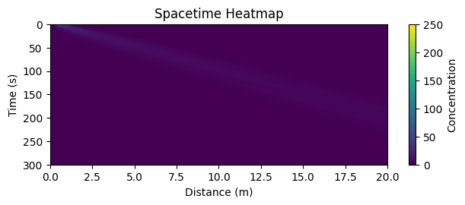
Test for dx = 0.8
This is a simulation calculator for the evolution of a pollutant concentration in a river
information needed for calculation: (ensure all inputs are +ve and non-zero)

choose simulation initialization:
test case 1 : where x_max = 20m, spacial resolution Δx = 0.2m, Model time = 300s, temporal resolution Δt=10s, flow velocity U=0.1m s−1, concentration μg m−^3 250 at x=0, 0 elsewhere)
test case 2 : initialise data for x_max, Δx and concentration distribution is read from initial_conditions.csv, with Model time = 300s, temporal resolution Δt=10s, flow velocity U=0.1m s−1
test case 3 : manual inputs
choose simulation initialization:
which test do you wish to run?3
what is the width of the model space (m) must be integer, x_max:20
Enter the space increment value (spatial resolution) (m), dx:0.8
Enter the model run time (s) must be integer, t_max:300
Enter the temporal resolution (s), dt:1
Enter the mean advective velocity (ms^-1), U:0.1
what is the start concentration at point x = 0:250
what is the start concentration at point x = 1:0
what is the start concentration at point x = 2:0
what is the start concentration at point x = 3:0
what is the start concentration at point x = 4:0
what is the start concentration at point x = 5:0
what is the start concentration at point x = 6:0
what is the start concentration at point x = 7:0
what is the start concentration at point x = 8:0
what is the start concentration at point x = 9:0
what is the start concentration at point x = 10:0
what is the start concentration at point x = 11:0
what is the start concentration at point x = 12:0
what is the start concentration at point x = 13:0
what is the start concentration at point x = 14:0
what is the start concentration at point x = 15:0
what is the start concentration at point x = 16:0
what is the start concentration at point x = 17:0
what is the start concentration at point x = 18:0
what is the start concentration at point x = 19:0
concentration distribution :
[250. 0. 0. 0. 0. 0. 0. 0. 0. 0. 0. 0. 0. 0.
0. 0. 0. 0. 0. 0. 0. 0. 0. 0. 0. 0.]
model space:
[ 0. 0.8 1.6 2.4 3.2 4. 4.8 5.6 6.4 7.2 8. 8.8 9.6 10.4
11.2 12. 12.8 13.6 14.4 15.2 16. 16.8 17.6 18.4 19.2 20. ]
model time:
300

choose initialization for calculation
calculator 1 (for questions 1,2,3) : regular advection calculation done
calculator 2 (for questions 4) : advection calculation modelled with exponential decay of concentration with time
calculator 3 (for questions 5) : advection calculation with variable velocity profile
which test do you wish to run?1
we will use the advection equation: ∂𝜃/∂𝑡 = ― 𝑈 * ∂𝜃/∂𝑥
courant number: 0.125
calculated result:
[[2.50000000e+02 0.00000000e+00 0.00000000e+00 ... 0.00000000e+00
0.00000000e+00 0.00000000e+00]
[0.00000000e+00 3.12500000e+01 0.00000000e+00 ... 0.00000000e+00
0.00000000e+00 0.00000000e+00]
[0.00000000e+00 2.73437500e+01 3.90625000e+00 ... 0.00000000e+00
0.00000000e+00 0.00000000e+00]
...
[0.00000000e+00 1.86741898e-16 7.92319197e-15 ... 4.81633257e-02
8.22665502e-02 1.34172826e-01]
[0.00000000e+00 1.63399161e-16 6.95613571e-15 ... 4.55021275e-02
7.80036471e-02 1.27684541e-01]
[0.00000000e+00 1.42974266e-16 6.10704364e-15 ... 4.29765130e-02
7.39409572e-02 1.21474430e-01]]
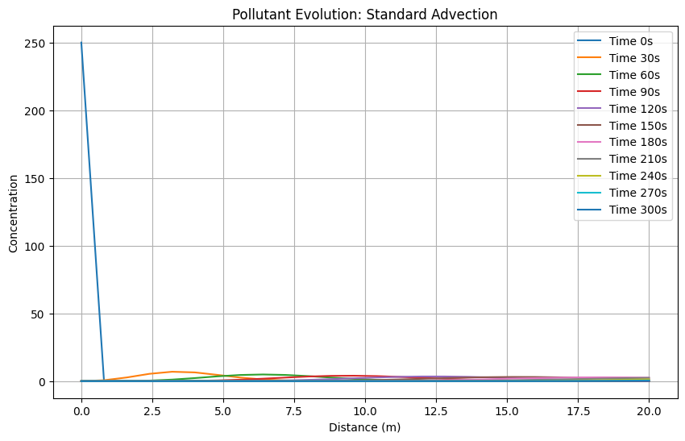
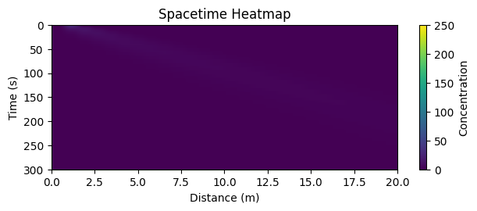
the larger the dx we can observe that the smearing / diffusion of the initial concentration is greater. This is seen as the peaks of the pollutant at time t have become lower and the curves become flatter.

